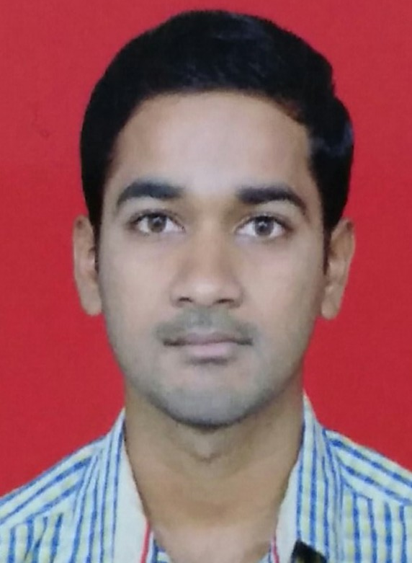
A.MURALI
CONTACT
Phone  : 7899433676
E-mail  : murali.sdba1@gmail.com

ADDRESS:

chittoor dt, A.P,
pin:517236

▪ Name -A.MURALI
Nationality - Indian
▪ Experience - Fresher
▪ Availability - Full Time
▪ Interests -
⬇ Listening to Music
⬇ Drawing & Painting
⬇ Cooking

OBJECTIVE

ABOUT ME

▪ Aim - To gain practical experience and expertise in
handling various functions.
- To achieve professional excellence with the best
utilization of my knowledge, potential and skills
thereby contributing my best toward the field of
and the organization.

EDUCATION
SKILLS

 S.V.P.C.E.T,PUTTUR ▪ Computer proficiency
B.TECH(CSE)

⬇ MS-Office - Word, Excel,
Percentage – 61.76% PowerPoint
 SENIOR SECONDARY ⬇ Internet and e-mail
M.P.C
Operations
Percentage - 82% ▪ Possesses good
 vijaya krishana juniour college ⬇ Communication,
S.S.C

Interpersonal &
Percentage – 76% Organizational skills
 viswa jyothi high school ▪ Can effectively work
in teams.

LANGUAGES
LANGUAGES

▪ English (Fluent)
▪ Telugu (Fluent)

DECLARATION
LANGUAGES

I hereby declare that the details mentioned above are true to the best of knowledge.
Date :
Place : murali

